**ASSIGNMENT NO 1 (THEORY)**

|  |  |
| --- | --- |
| **NAME:** | **WAJAHAT NAZIR** |
| **REG. NO:** | **SP24-BSE-122-(B)** |
| **COURSE:** | **OOP** |

Demonstration of code output:

Saving s contact:

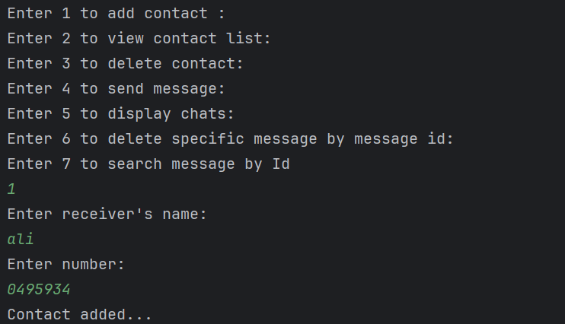

Displaying contact list after adding few contacts:

Sending a message:

Displaying messages for first time in unread form:

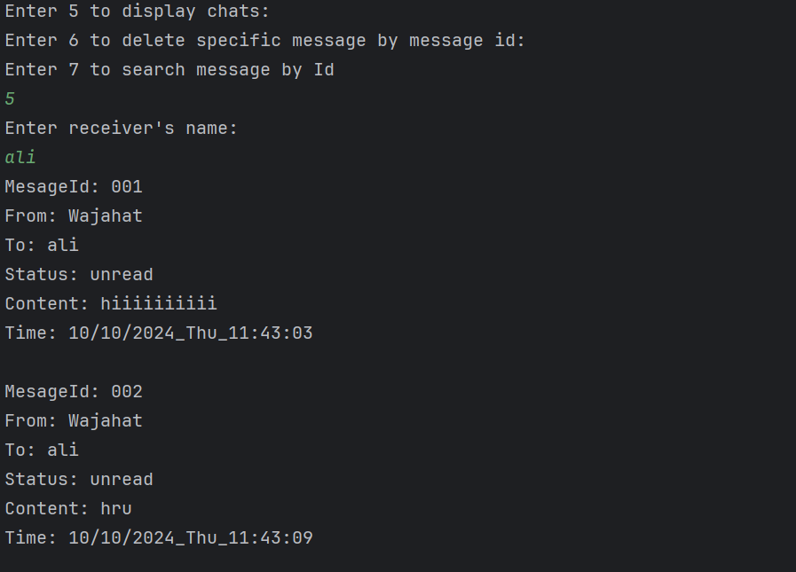

Read message displayed for second time:

Deleting message by id:

Searching and displaying specific message by id:

Deleting contact completely:

Remaining contact list:

